KeyKeeper V2.0 Guide Book

--------------------------------------
(KeyKeeper) V2.0 2010.2.
Author: Ye JiaYing
Email: kevin.ye32@gmail.com
Running Environment：Above Windows 2000 (NOT Support Windows 2000)
Source files are in the “Source” folder.
Features of KeyKeeper V2.0:
With Skins, more beautiful.
Encryption for all files (add .exe .zip *.* supported)
Showing procedure while taking actions
Introduction of KeyKeeper V2.0
Purpose：
With the fast development of high technology, there are more and more criminals peeping others’ private files. In order to protect the files, KeyKeeper was born.
3 main functions of KeyKeeper (Can be chosen on the top bar of the Main Form)：
1、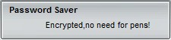
2、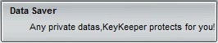
3、

First function
Designed for the people who have a great deal of accounts and passwords. Whenever you forget you account, password or the answers to Security Questions, you can login the KeyKeeper and find out easily.
Support: Title
Name (for account)
Password, details (for Security Questions)

Second function
Designed for people who want to save private texts (e.g. schedules)
Support: Title
Details (private texts)
Third function
Designed for people who want to encrypt their files
Notes：
1) Longest password is 24 words.
2) Encrypted files will turn into (.enc) files
3) Decryption for .enc files ONLY.
WARNING:
Actions can be taken whether password is correct OR NOT, but only with the correct one can the data be able to read or write.
This function is powered by AES Encryption which is the safest standard of encryption for civil use.
So, enjoy the safety after encrypting.
Notes for KeyKeeper V2.0
Main Application
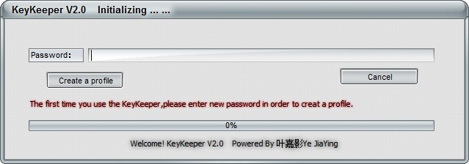
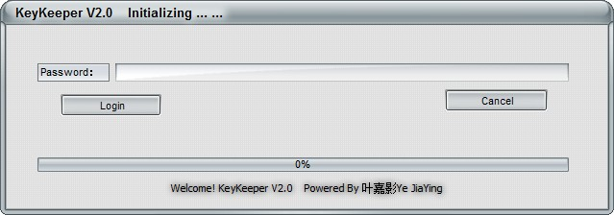
The first time you run KeyKeeper, you need to enter a password for creating a new profile. (first form)
Or, you see the second from
Editing bar: the buttons for “Save”, “Add” and “Cancel”
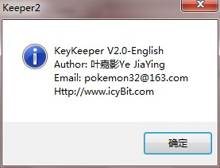
The About Box

